ADSA _LAB3

* BST Creation, Traversal
* Diameter of BST
* No of leaf nodes, Internal Node, height of BST

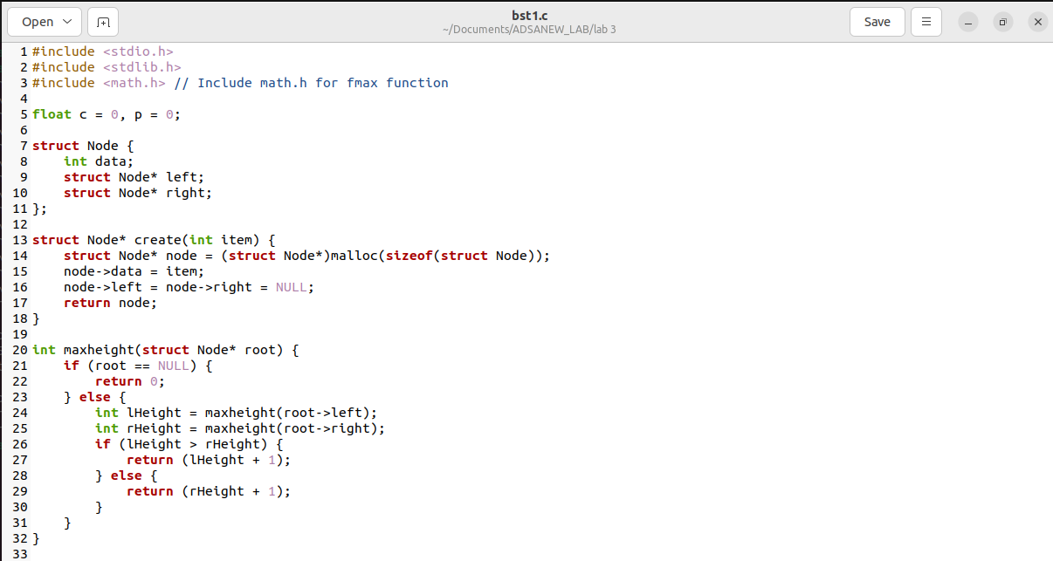

Analysis:

Time Complexity:

Insertion (create):

* Best Case: O(log n) for balanced trees.
* Worst Case: O(n) for completely unbalanced trees.
* Average Case: O(log n) with random insertions in balanced trees.

Traversal (inorder, preorder, postorder):

* Always O(n) because each node is visited once.

Height Calculation (maxheight):

* Best Case: O(log n) for balanced trees.
* Worst Case: O(n) for completely unbalanced trees.
* Average Case: O(log n) with random insertions in balanced trees.

Diameter Calculation (diameter):

* Best Case: O(n) for balanced trees.
* Worst Case: O(n) for completely unbalanced trees.
* Average Case: Varies but often close to O(n) with random insertions.